

P. swethanagasri
SURABHI ANUSHKA

2520090168
CSIT
CO6

Case Study Topic: CivicEye – Smart City Incident Monitoring & Response System

Work Done Summary:
CivicEye is a smart city monitoring system that helps municipal authorities respond quickly to incidents such
as accidents, fire outbreaks, traffic congestion, and public safety emergencies. Multiple incidents are reported across the city, but emergency response teams and vehicles are limited. The system must determine the optimal
set of incidents to prioritize in order to maximize public safety impact within available resources. This problem
is solved using the 0/1 Knapsack Dynamic Programming Algorithm
Implementation Details:
- Each incident is assigned a severity score and required response time.
- Emergency vehicles have limited operational capacity.
- Each incident can either be selected or not selected for immediate response.
- Dynamic Programming is used to optimize incident selection.
- A DP table stores the maximum severity coverage for available resources.
- Include and exclude decisions are evaluated for every incident.
- The algorithm identifies the best combination of incidents.
- The selected incidents maximize public safety impact.
Output:
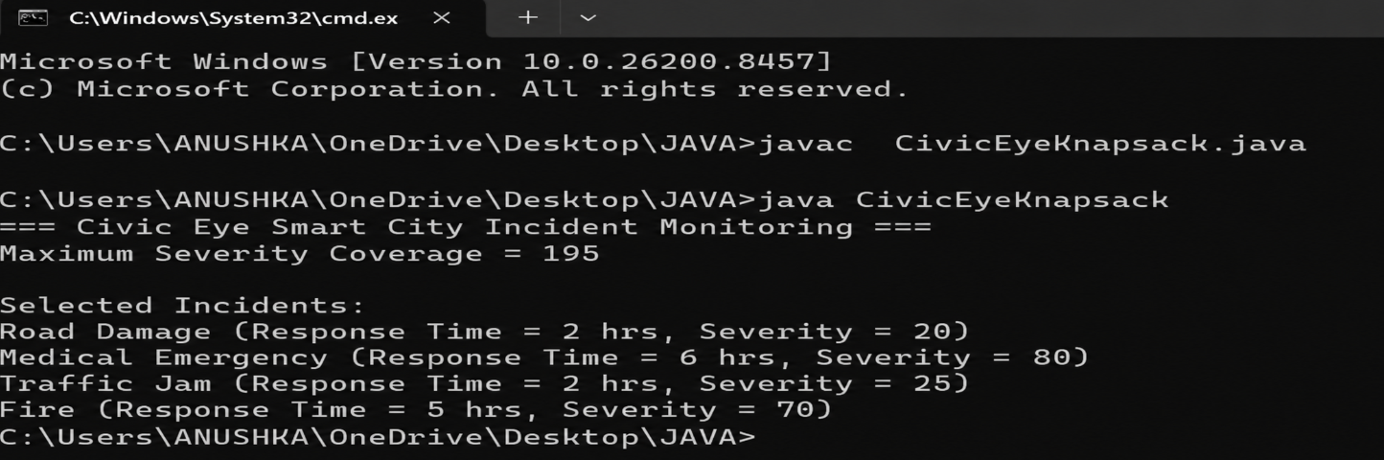
CivicEye successfully demonstrates the application of Dynamic Programming in smart city management.
By selecting the most critical incidents within limited response capacity, the system improves emergency
handling efficiency and resource utilization. This approach can be used in real-world smart cities for
disaster management, public safety, and emergency response optimization.
Github link:

